**Exercise 1 - Dawson**

import java.awt.*;

public class DrawLoop

{

public static void main(String[] args)

{

DrawingPanel panel = new DrawingPanel(400, 200);

panel.setBackground(new Color(200, 250, 150));

Graphics g = panel.getGraphics();

int sizeX = 50;

int sizeY = 25;

for (int i = 0; i < 8; i++)

{

int cornerX = i*50;

int cornerY = i*25;

if (i%2 == 0) {

g.setColor(Color.ORANGE);

}

else {

g.setColor(Color.GREEN);

}

g.fillOval(cornerX + 5, cornerY + 5, sizeX-10, sizeY-10);

g.setColor(Color.BLACK);

g.drawRect(cornerX, cornerY, sizeX, sizeY);

}

}

}

**Output**

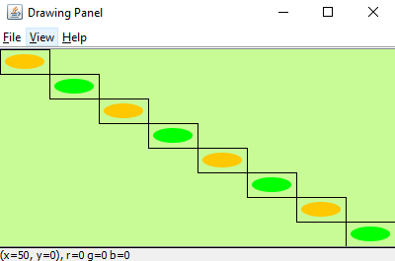

**Exercise 2**

if (x >= 5) {

g.setColor(Color.green);

}

else {

g.setColor(Color.yellow);

}

**Exercise 3**

if (x == y) {

g.setColor(Color.green);

}

else {

g.setColor(Color.yellow);

}

**Exercise 4**

if (x <= y) {

g.setColor(Color.green);

}

else {

g.setColor(Color.yellow);

}

**Exercise 5**

if (x + y <= 9) {

g.setColor(Color.green);

}

else {

g.setColor(Color.yellow);

}

**Exercise 6**

if ((x + y)%2 == 0) {

g.setColor(Color.green);

}

else {

g.setColor(Color.yellow);

}

**Exercise 7**

if(x == 3) {

g.setColor(Color.GREEN);

}else if(x == 4) {

g.setColor(Color.BLUE);

}else if(x == 5) {

g.setColor(Color.RED);

}

else {

g.setColor(Color.yellow);

}